Assignment 6
Please read turn-in checklist at the end of this document before you start doing exercises.
Problems To Hand In (Java Implementation):

- Create an adjacency list to represent the following graph in Java.
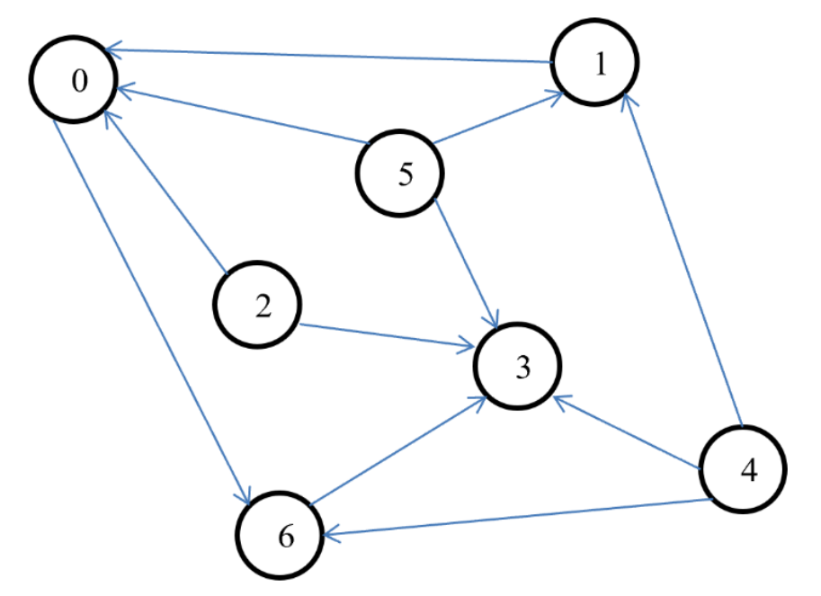
Note:
Find a file called Graph.java in assignment 6 folder.
Complete the getAdjList() method to create an adjacency list to represent the given graph and print its adjacency list.
Test your method in the main method provided following the comments.

- We discussed how to traverse a graph using DFS.
Implement DFS traversal in Java.
Note:
Find a file called Graph.java in assignment 6 folder.
Complete the method of DFS().
Test your method in the main method provided following the comments.

Problems NOT to Hand In (Practice Problems):
The following problems are NOT collected and NOT graded. However, some of these problems will be used in quizzes, so it is in your best interest to do practice problems.
Solutions to practical problems will be discussed AFTER quizzes (To be fair with the class, the instructor will NOT answer questions about practice problems BEFORE quizzes. If asked, the instructor will show similar problems discussed during lectures).

- Leetcode 323:
https://leetcode.com/problems/number-of-connected-components-in-an-undirected-graph/
https://www.geeksforgeeks.org/connected-components-in-an-undirected-graph/

- Leetcode 1059:

https://www.geeksforgeeks.org/find-paths-given-source-destination/
https://leetcode.com/problems/all-paths-from-source-lead-to-destination/

- Leetcode 2360:
https://leetcode.com/problems/longest-cycle-in-a-graph/

TURN-IN CHECKLIST:

- All your source code* of “Problems To Hand In”. Remember to include your name, the date, and the course number in comments near the beginning of your code.

* The source code you submit must contain all the files necessary to run your program. These files will typically be .java files containing programs.

- Create a folder and name it 'FirstName_LastName_assignment_6'. In the newly created folder copy and paste your files (.java files). Then compress the folder, and push it to Brightspace.

